

MOBILE APPLICATION-BASED TAXI METER
DEPARTMENT OF ELECTRICAL AND INFORMATION ENGINEERING
FACULTY OF ENGINEERING
UNIVERSITY OF RUHUNA
AN UNDERGRATUATE PROJECT PROPOSAL
SUBMITTED IN PARTIAL FULFILMENT OF THE DEGREE OF THE BACHELOR OF THE SCIENCE OF ENGINEERING
ON
07TH NOVEMBER 2025

EE5206: SOFTWARE PROJECT
GROUP MEMBERS
HAMID K. K. J. : EG/2022/5055
MUNASINGHE M. A. B. M. : EG/2022/5198
PERERA M. T. J. P. : EG/2022/5239
RODRIGO W. T. N. : EG/2022/5297

Approved by : ………………………………
Client : Dr. Subodha Gunawardena
Department of Electrical and Information Engineering,
Faculty of Engineering , University of Ruhuna
ABSTRACT
This project proposes the development of a Mobile Application-Based Taxi Meter System designed to simplify and digitalize taxi fare calculation while promoting transparency between taxi drivers and passengers. Each registered taxi driver will receive a unique QR code issued by the government. Customers can scan this QR code to view the driver’s per-kilometer rate, compare rates across areas, and negotiate fares before confirming a ride.
The system will allow taxi drivers to set or update their per-kilometer rates and automatically generate trip receipts after each journey. Receipts will be securely stored in a database for future reference and income tracking.Additionally, the app will compute average per-kilometer prices in specific regions, visually indicating whether the current rate is above or below average.
The proposed system will prioritize minimal data interaction to ensure fast responses and offline functionality, allowing continued use even during central server outages. This project aims to enhance transparency, efficiency, and security in local taxi operations through an easy-to-use and data-light mobile platform.

ACKNOWLEDGEMENT
We extend our gratitude to our client, Dr. Subodha Gunawardena, for providing valuable insights and requirements that guided the direction of this project.

Contents

1 Introduction 1
1.1 Background 1
1.2 problem statement 1
1.3 objectives and scope 1
1.4 Methodalogy 2
1.5 Time plan and resources required 3
1.5.1 Time plan 3
1.5.2 Resources required 3
2 Requirements 4
2.1 Functional requirements 4
2.2 Technical requirements 5

Table of Figures
Figure 1 Project Timeline and Task Schedule for Taxi Driver Verification System Development 3
Figure 2 System Architecture of the Taxi Meter Application. 5

Introduction

Background
Traditional taxi services often rely on mechanical or digital taxi meters that are costly to install and maintain. Meanwhile, modern taxi-meter apps charge high commissions, reducing drivers’ profit margins. Many independent drivers lack access to affordable, transparent systems to display their fare rates to customers. A mobile application that acts as a smart taximeter can overcome these limitations by providing a convenient and flexible solution for both drivers and passengers.

problem statement
The absence of a unified, commission-free, and transparent system prevents drivers from independently setting their rates while maintaining customer trust. Customers, on the other hand, face difficulty verifying the authenticity of drivers and their fare rates. Furthermore, server-dependent applications often fail during connectivity issues, limiting reliability. Therefore, there is a need for a lightweight, offline-capable mobile app that provides QR-based verification, rate visibility, and automated fare calculation.

objectives and scope
Objectives:
- To implement a QR-based verification system that identifies registered taxi drivers and provides customers with access to verified driver information and fare negotiation capabilities.
- To implement dynamic fare management with area-wise average rates, visual indicators, digital receipt generation, and trip record maintenance for transparency and accountability.
- To enable income tracking and reporting functionalities for drivers to monitor earnings and for regulators to oversee driver activity and support data-driven governance.
- To ensure system reliability through offline support for fare calculation and essential functionality.
Scope:
- The system will be implemented as a mobile application with optional web dashboard for government regulators.
- A local database will store receipts and driver data, with optional synchronization to a central database.
- The app will provide minimal data interaction for quick response and efficient performance.

Methodalogy
- Mobile Application Development: The app will be developed using Flutter or React Native for cross-platform compatibility. Core features include QR scanning, rate setting, trip tracking, and receipt generation.
- Database Management: A local SQLite database will handle offline data storage. Optional synchronization with a cloud database (Firebase or MongoDB Atlas) will be included for central data access.
- Backend and APIs: A lightweight Node.js/Express backend will manage user authentication, rate storage, and government verification.
- Testing and Deployment: Functional and performance testing will ensure quick response and reliable offline use. The final product will be deployed on Android devices, with web access for regulators

Time plan and resources required

Time plan

Figure 1 Project Timeline and Task Schedule for Taxi Driver Verification System Development

Resources required
- Development platforms: VS Code
- Technologies: Flutter, Node.js and Express, SQLite/Mongo DB
- Devices: Android smartphones for testing
- Internet connection for synchronization and deployment

Requirements

Functional requirements

- Driver Registration & Verification: Government registration and QR code generation.
- Secure Driver Data Storage: Driver details are stored securely in the system.
- Rate Management: Drivers can set or update their per-kilometer rate; customers can view and negotiate rates.
- Driver Discovery: Customers search for nearby drivers and choose a driver based on the displayed price.
- Ride Requests: Drivers receive customer ride requests through the app.
- Trip & Receipt Management: The system performs automatic fare calculation and generates digital receipts.
- Area-wise Rate Analysis: The system calculates average rates for each area and displays color indicators (red for high, green for normal).
- Offline Functionality: The app supports local fare computation and receipt generation without an internet connection.
- Regulator Dashboard (Optional): Allows regulators to manage driver accounts and monitor rates.
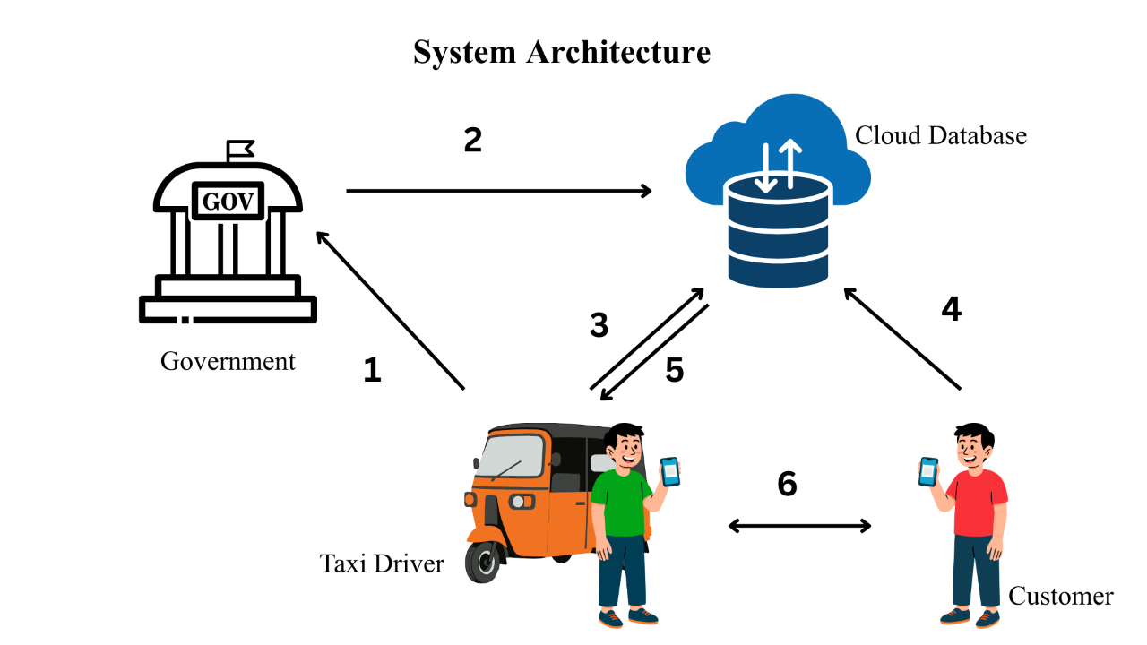
Figure 2 System Architecture of the Taxi Meter Application.
The numbered arrows (1–6) in the Figure 2 correspond to the Functional Requirements listed in Section 2.1. Each number represents the workflow step described in the requirements: government verification (1–2), driver rate updates (3), customer driver search (4), customer–driver communication through the cloud (5), and offline fare calculation during the trip (6).

Technical requirements
- Frontend : Flutter
- Backend : Node.js + Express
- Database : SQLite (offline) + MongoDB (online)
- QR Code Generation : QR Flutter / QR.js
- Authentication : JWT or Firebase Auth
- Hosting : Microsoft Azure
- Tools : Android Studio, Postman, Figma for UI design

